Fuse Box Mechanic

Overview

Currently when the player is searching for the memories there is nothing else to it except a slow countdown which will randomize the object locations again. The idea behind the fuse box will be to give the player another mechanic to keep the game interesting and fun.

How it works

* The fuse box is an old coin-fed machine which is dependent on the player feeding coins into the machine for electricity
* Player will need to keep the fuse box active to keep the electricity in the house on. Players do this by putting coins into the coin feeder and cranking the coin in before they run out of power.
* Cranking the coin feeder is done by repeatedly clicking the knob to turn it completely around to feed the coin into the machine.
* Players must search for coins which will be located around the house. There will be a limited amount of coins that the player can find during each stage though.
* Players should not let the meter run out of money (which is done when the timer for the meter turns to 0). If the meter runs out then the power in the house stops, making the lights turn off and making it harder to see.
* If the player does not put in another coin into the meter in time The Carer will go looking for the player. If The Carer runs into the player then it will be the same as being caught in a puzzle.
* Different coins give different amounts of time. Players will know how long they have left by an indicator on the fuse box as well as the lights of the house will start to flicker.
* Players cannot feed in every coin into the machine in one go. The player can only put in a maximum of two coins every 5 minutes. This is to force players to strategize with choosing what coins to put in to the machine due to how limited they are.
* Players can also be caught by The Carer when they are feeding and cranking the meter like in the puzzle.

Steps to putting coins into the machine

1. Players must first find a coin and click on it to pick it up (can only carry one coin at a time)
2. Players must go to the machine and press space to enter its interface (Reminder: when players are in this interface The Carer can catch them)



Above is what the interface for the electric box could look like. The idea behind it is to make the action of feeding coins into the machine have more meaning and interaction. The player does this by:

* Feed the coin into the machine (By clicking where number 1 is)
* Then repeatedly tapping the crank (number 2) until it has done a complete rotation around.
* The light display indicates to the player when they can put a coin in. The light display will go off once a player has put in a coin and won’t come on for a short length of time to prevent the player from continually feeding coins into the machine.

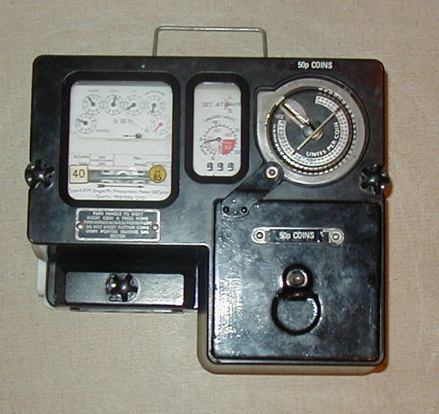

Above is an image of an old coin machine which this mechanic bases loosely off of. However the dials will be simplified to just one timer and the player cannot change the electricity rate. Plus the coin feeder accepts different coins to simplify gameplay rather than having multiple coin feeders for different coins.

Difficulty

* Players are limited to what coins they can find lying around the house. If the player cannot find anymore coins then they must complete the memory to prevent being caught by The Carer.
* Players can be caught whilst cranking the coin machine by The Carer and must be aware when The Carer is near.
* With using different coins for the machine means player can strategize with what coins to put in first. Players can pick up coins and place them somewhere easy to remember so they can put them into the machine when they need to.
* Since the player can only put in a few coins at a time prevents the player from just constantly feeding in coins into the machine. The machine will have a light which when active will indicate that the player can put in another coin if they want to.